Melbourne Fashion Week

20-26 October

Social Story

M/FW Runways

As a commitment to inclusion and accessibility, we have created this social story to support you to prepare for what you will see, hear and do.

If you require more information, have specific questions or would like an accessible version of this document, please get in touch with us at mfwticketing@melbourne.vic.gov.au

We can also be contacted via:
- City of Melbourne Customer Service Team 9658 9658
- National Relay Service 1300 555 727
I am going to an M/FW Runway.

I need to bring my phone and event tickets.

I can bring my own headphones, ear plugs, fidget tools or other sensory tools.
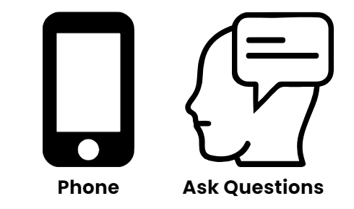
If I need assistance, I can wear a sunflower symbol so trained staff can offer help as a part of the Hidden Disabilities Sunflower scheme.
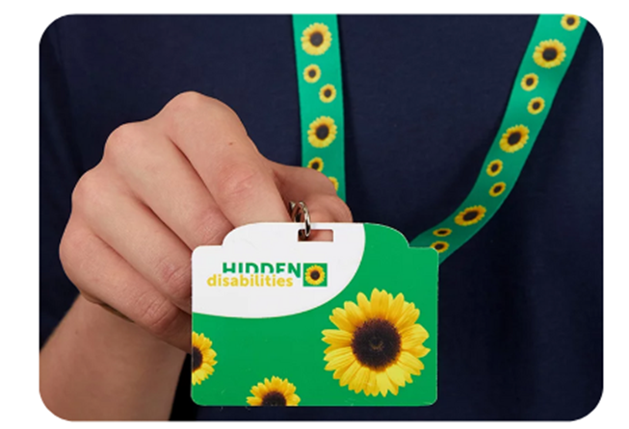

I can wear whatever I like to an M/FW Runway.
Some people like to wear their best clothes, others like to be comfortable.
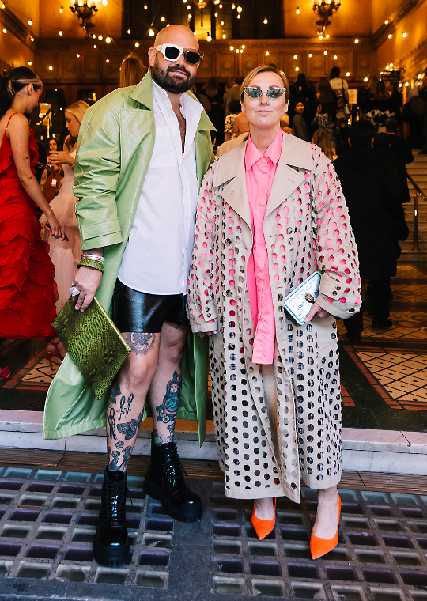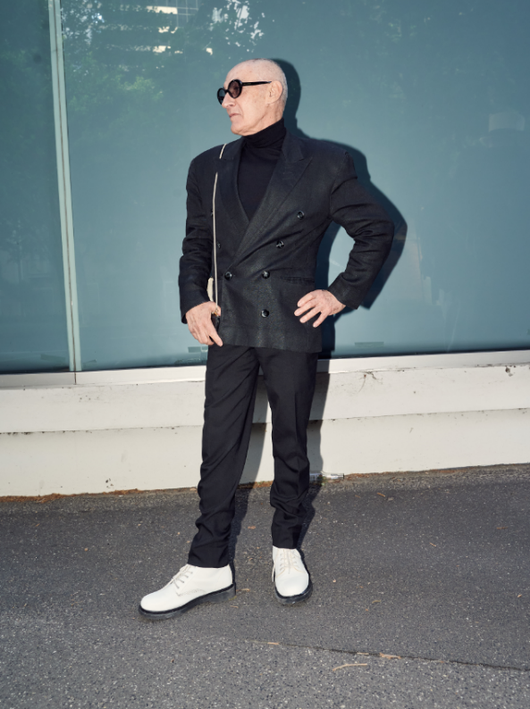
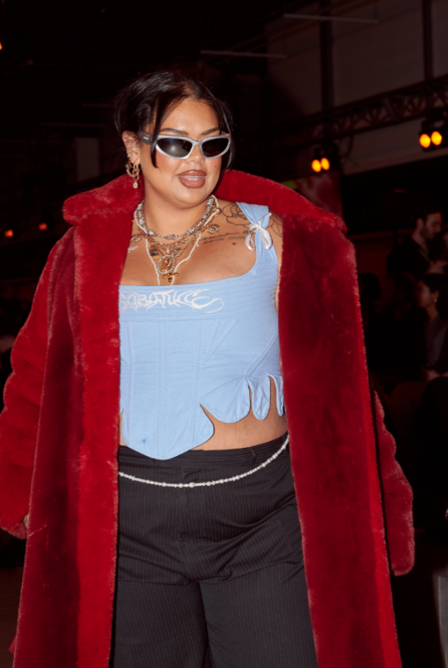
I know I am arriving at the entrance of an M/FW Runway when I see M/FW signage.
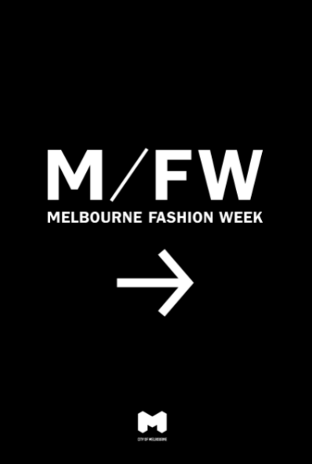

I might have to line up at the entrance and wait while doors to the runway open.
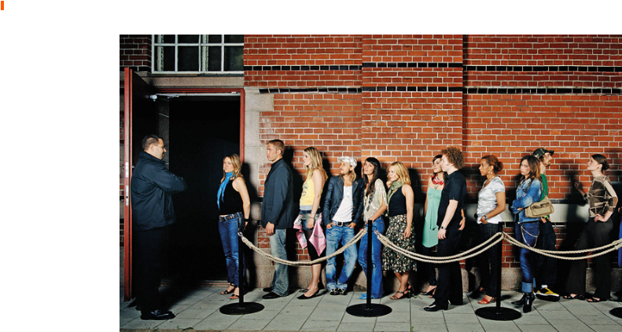
I can go to the Accessibility Concierge if I need help. The Accessibility Concierge is located near the entrance of each M/FW Runway.

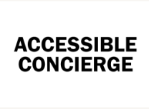

M/FW staff and volunteers will be there to help me also.
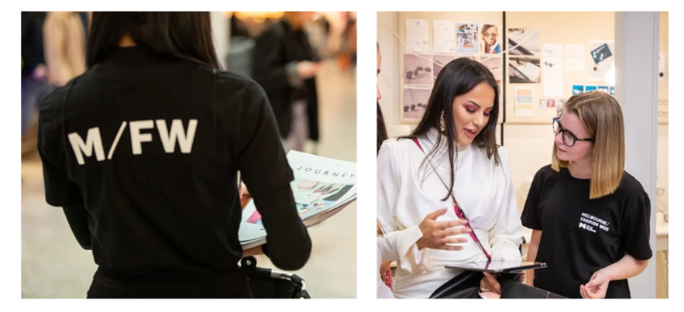
There might be celebrities, photographers and people videoing the crowds and me as I wait.
They will be wearing M/FW T-shirts and/or lanyards with rectangular cards telling me they are staff.
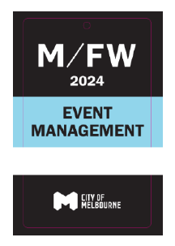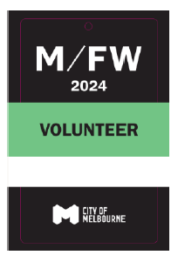
I will have my ticket scanned at the entrance of the runway.
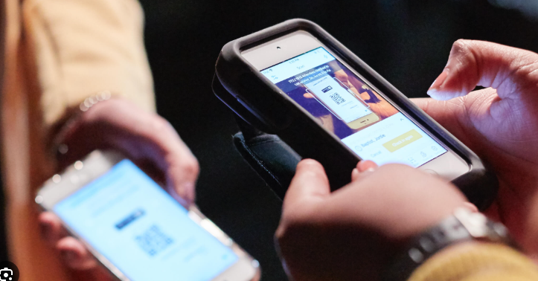

Once I am inside the runway venue, I can get my photo taken by a friend in front of a media wall.

There might be other activities I can take part of before the runway.
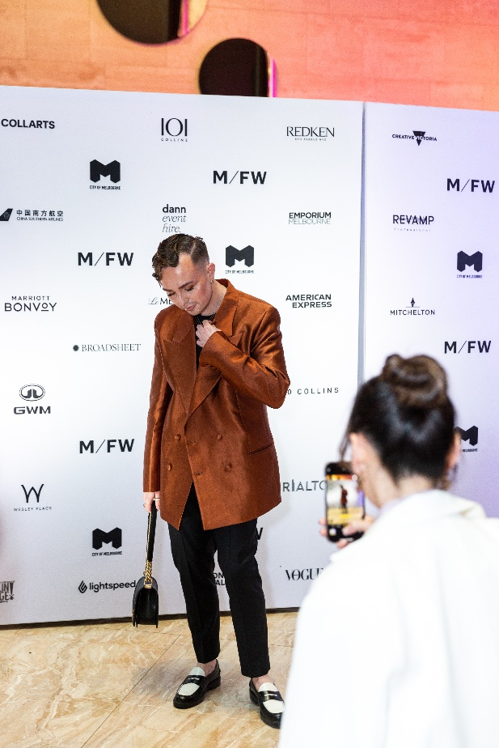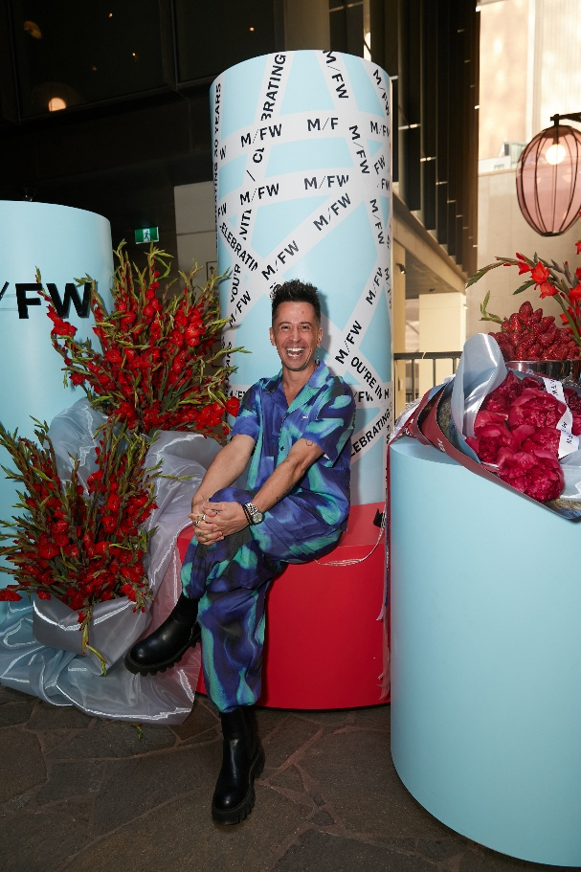

I cannot buy food or drink at an M/FW Runway.


At most runway shows one complimentary beverage is included in my ticket.
There is free drinking water.
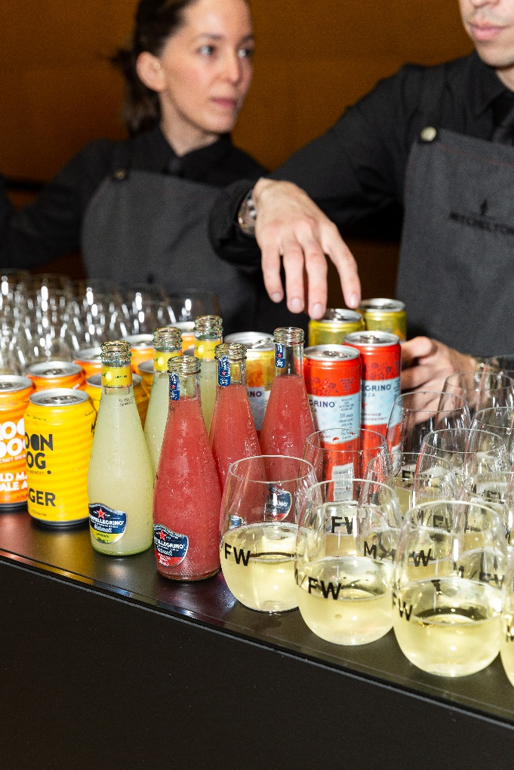
I can find the toilets, including accessible and gender-neutral toilets by following the signs or asking a team member.
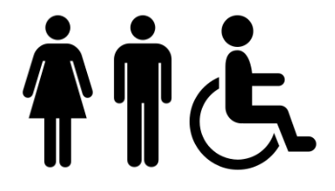

The venues have varied lighting states.
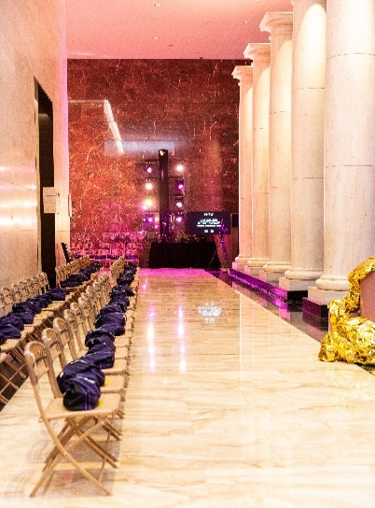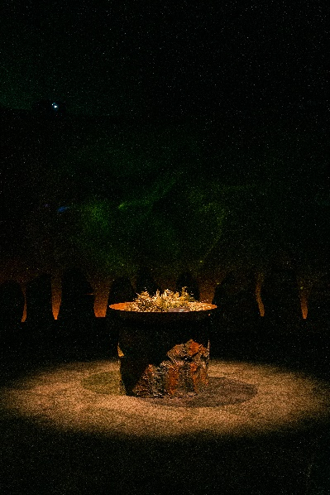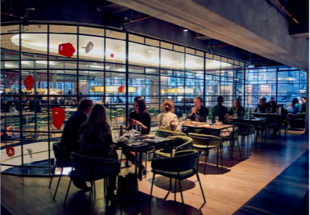
Some venues will be well lit, others will have low lighting, others a combination of both.
There are different ground and flooring surface types including smooth tiles, floorboards, carpet and concrete.
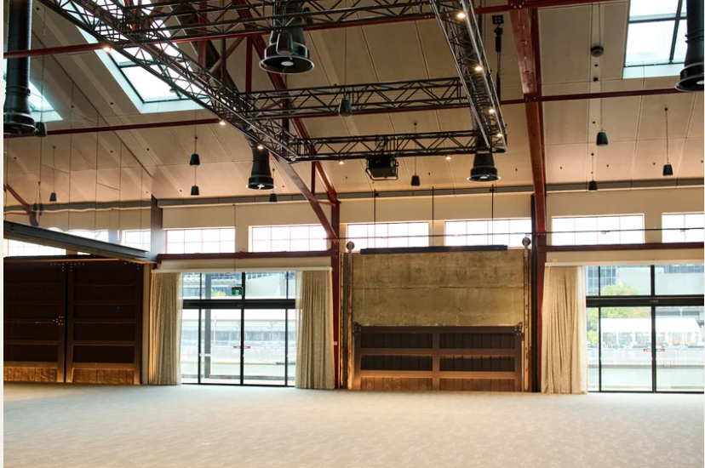
In some venues I might need to use stairs or an elevator to get to where I need to be.
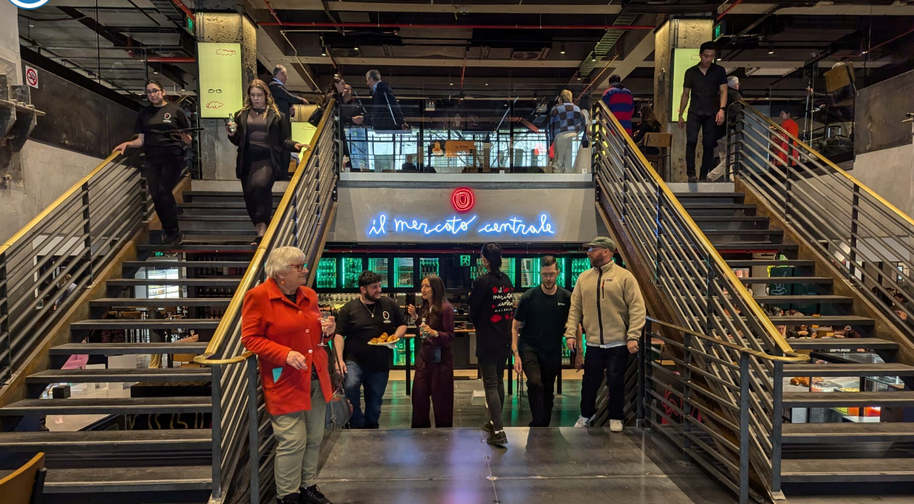
My ticket might include a gift bag, and I will find this on my seat of be given it at the end of the show.

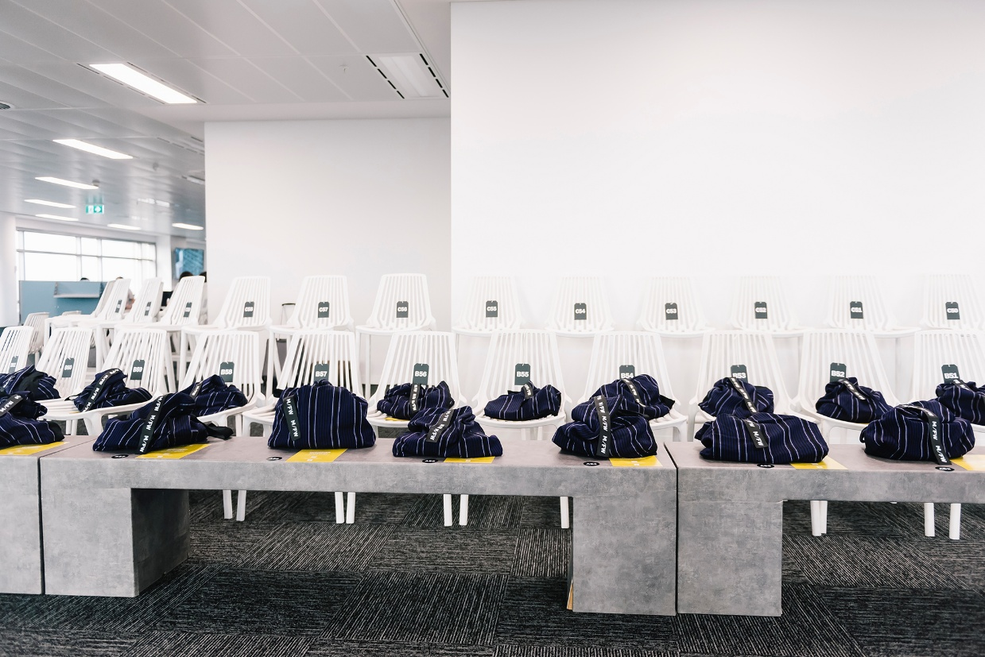

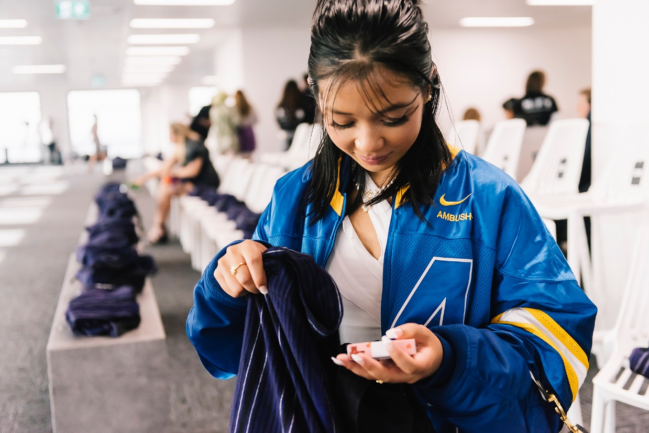
The runway may include:
- Loud music sustained for a long period.
- Loud or sudden noises or sound sustained for a long period.
- Intense bright lights.
- flashing lights.
- abrupt lighting changes.
- varied lighting states including low lighting.
- Mature themes.

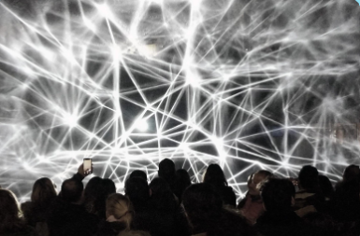
At the runway I will be able to see designers’ new clothes on models.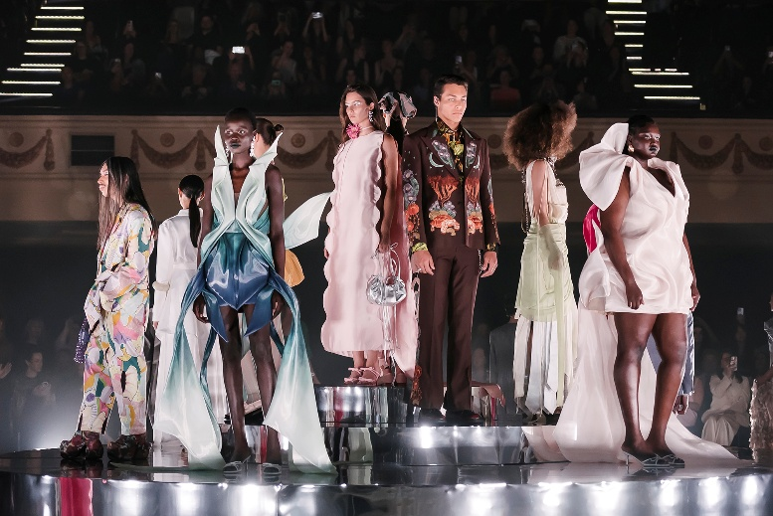 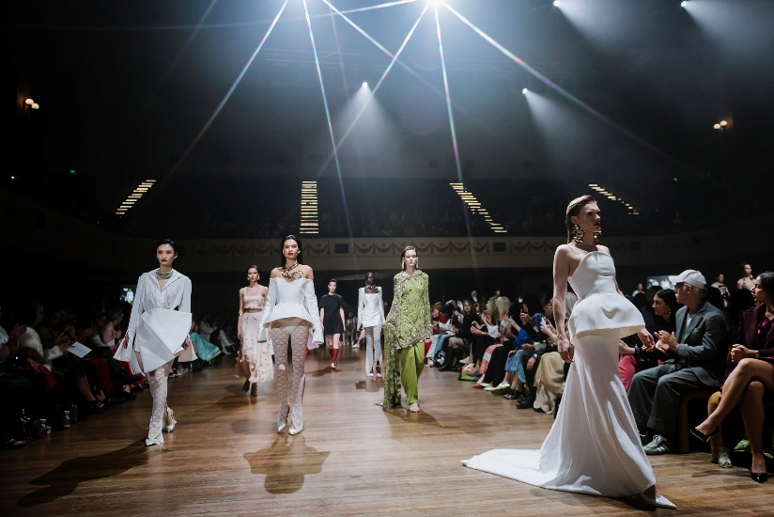

I might also see a performance by singers, dancers or musicians as a part of the show.
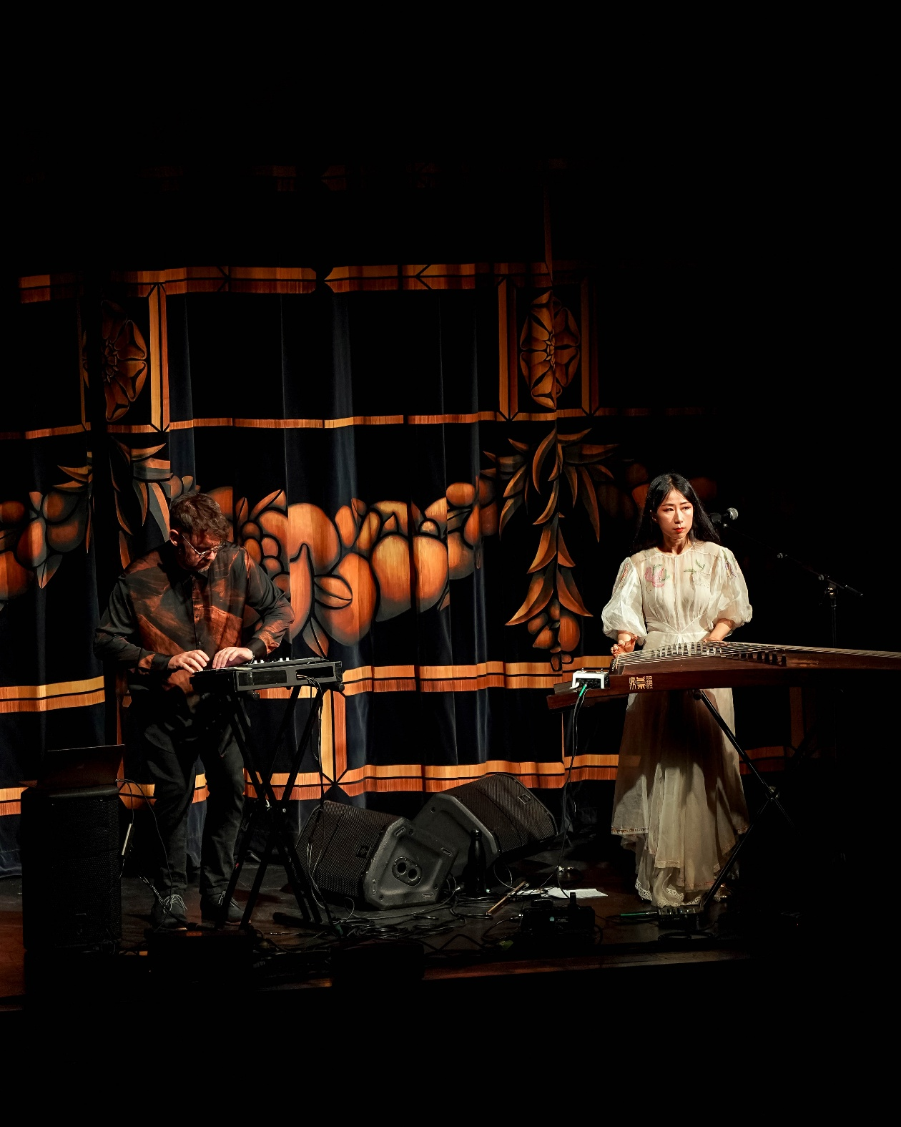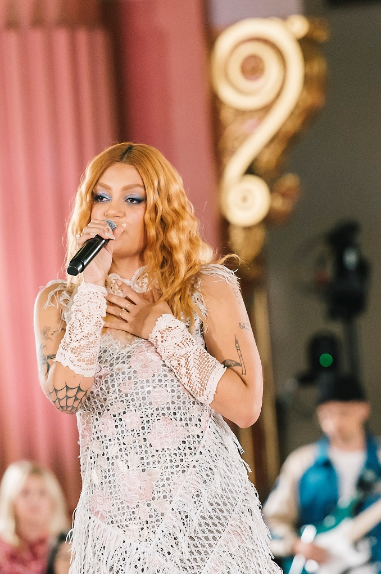

There are dedicated spaces called ‘Quiet Areas’ called at most runway venues.

Here I can sit, rest, and have some quiet time. The staff and volunteers can assist me with directions to get to these spaces.
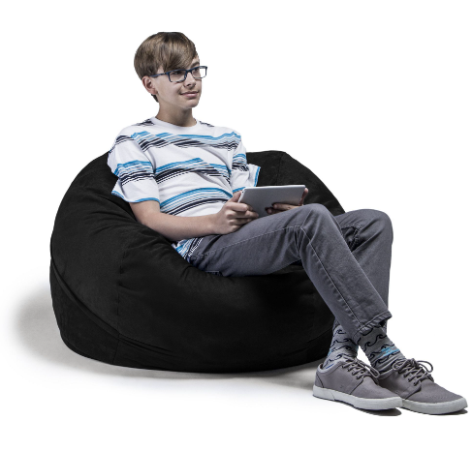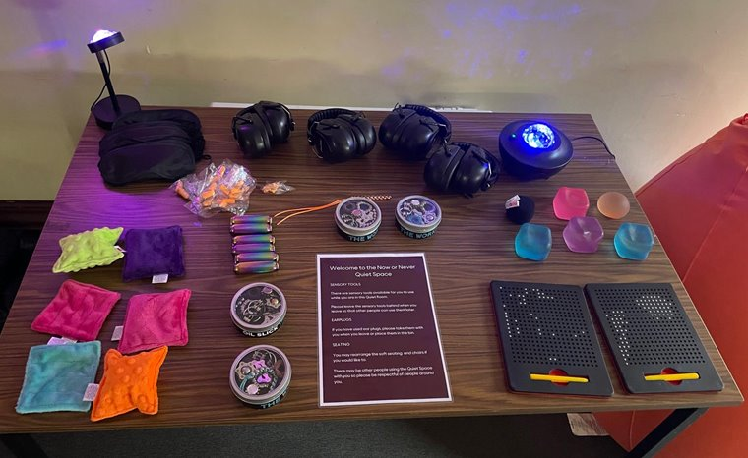

If I have another requirements or questions about the event, I can email the M/FW team at mfwticketing@melbourne.vic.gov.au.

